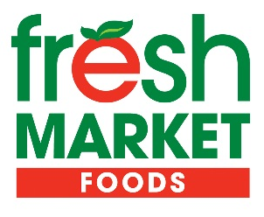

79 Queen Street ♦ PO Box 67 ♦ Sioux Lookout, ON ♦ P8T 1A1 ♦ 737-1630

Delivery Driver

Overview:
Are you a responsible driver who enjoys working with people? Fresh Market Foods is looking for dedicated individuals to join our team in delivering groceries to the local airport and in-town customers. If you're looking for a fast-paced environment where you can make a difference, apply now!

Duties/Responsibilities:
- Collaborate with the Order Desk Team in a dynamic environment to ensure the safe and prompt delivery of customer orders
- Perform pre-trip and post-trip inspection of vehicle
- Load and unload cargo, goods or merchandise
- Ensure company vehicles are properly maintained and promptly report any issues to the supervisor
- Provide customer service by selling products, delivering over established routes and accepting or making payments for goods
- Record information on pick-ups and deliveries, vehicle mileage and fuel costs and report any incidents or problems encountered
- Other duties as assigned

Qualifications:
- High school diploma or equivalent, with a combination of education and experience
- Clean driving record
- Strong ability to work independently
- Excellent customer service skills
- Capable of lifting heavy boxes (up to 50lbs)

Benefits:
- Vacation Pay: 10 vacation days after 1 year
- Medical & Dental Benefits, Long Term Disability, and RRSP program: Accessible after completing a 3-month probation period.
- Wellness Program: Access to Staff Wellness Program which encompasses the Fresh Market Foods Gym.
- Financial Flexibility: Dayforce Wallet for pay access when needed.
- Staff Discount: 10% discount at Fresh Market Foods and 20% discount at Your Dollar Store with More after 3-month probation.

Terms of Employment: Full-Time

Hourly Rate: Starting at $18.00/hour (depending on experience)

Application Deadline: Please ensure your application is submitted no later than March 29, 2024.

Apply with Resume or Application Form with Driver’s Abstract to:
Liz Ward, Human Resources Manager
Email: jobs@freshmarketfoods.ca

Fresh Market Foods is an equal opportunity employer. We encourage all interested applicants to apply. Reasonable accommodation will be provided during the hiring process.

